Source code
- Observation of CPU utilization graph for EC2 instance
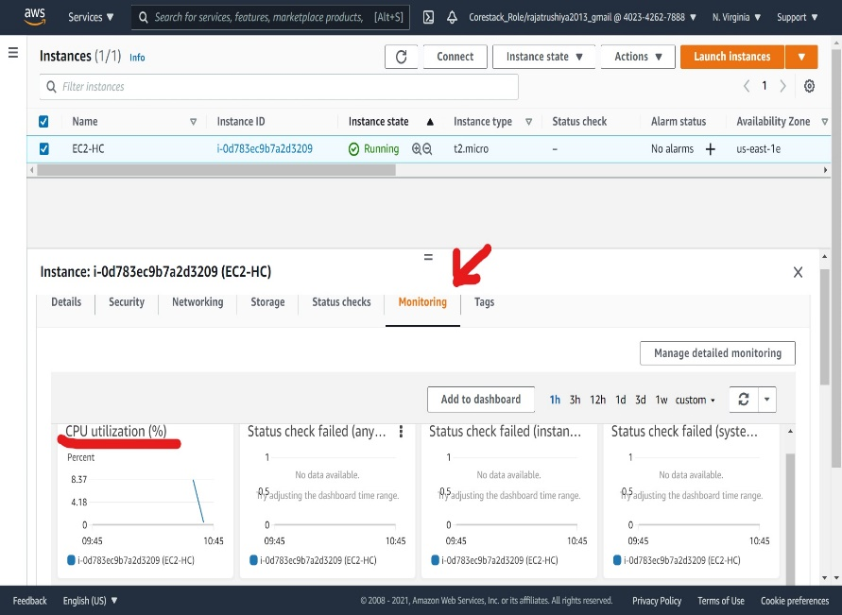
Launch EC2
Go to monitoring

- Creation and configuration of CloudWatch alarm
- Open CloudWatch console
- Select in alarm
- Select matric
- Click on EC2
- Per instance matric
- Check box of CPUUtiliation
- Click on select matric
- Provie condition
- Click on next
- Go EC2 Instance check in alarm section

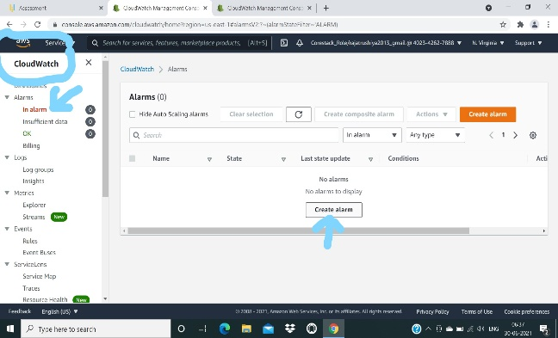
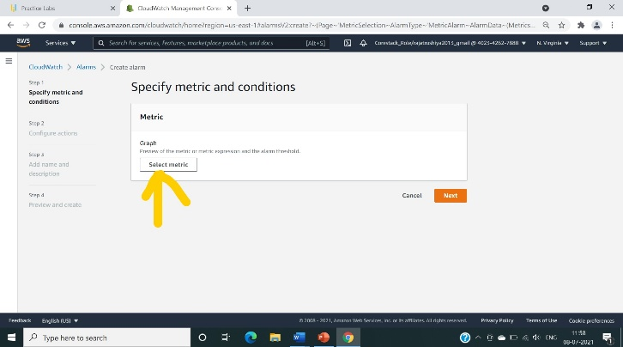
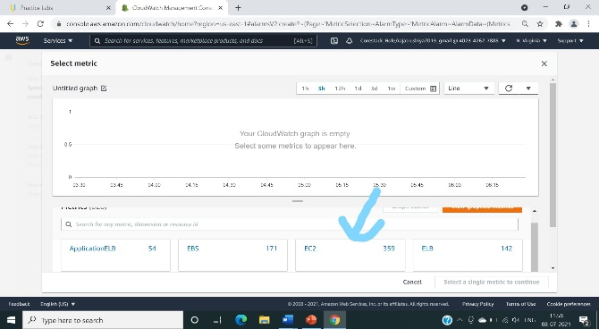
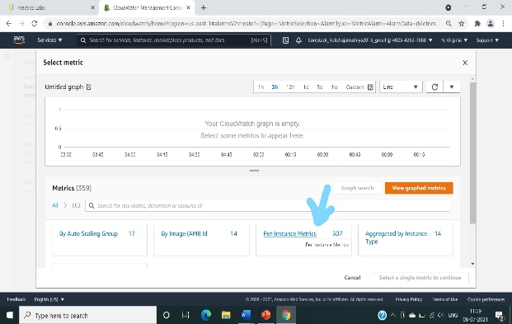
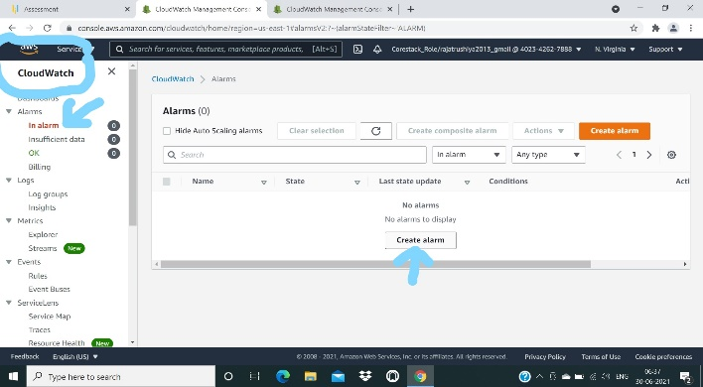
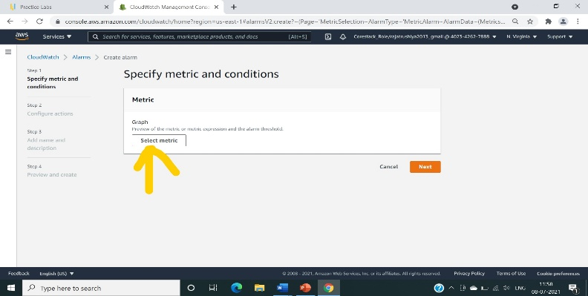
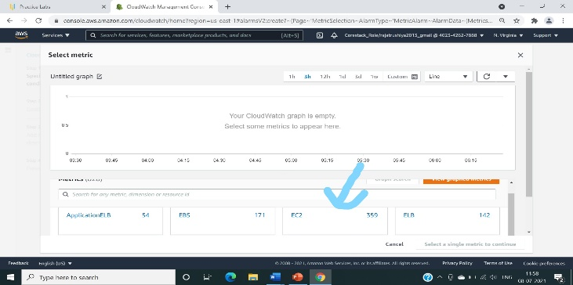
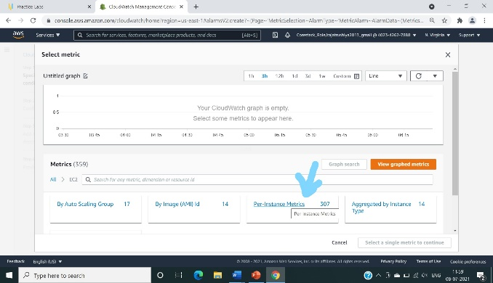

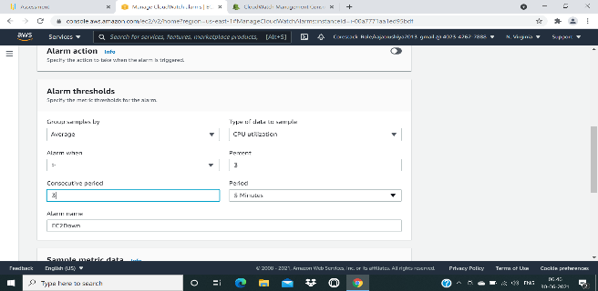

- Creation of IAM group and adding user to it
- Select IAM console
- Click on user group name the user group as Administrator and attach the full administration access policy to group next click on create group
- To add user, click on users
- Now click on add user
- Define the users name and select AWS access type.
- Now select add user to group from list choose group named Administrator
- Add tags click on Next: Review
- Now verify the users details and click on create user.

